ASSIGNMENT 3
1.Question: Create table EMPLOYEE with the given fields.
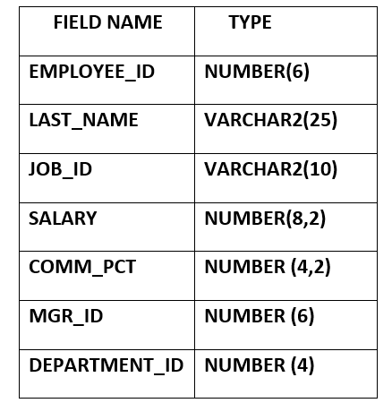
Query:
CREATE TABLE EMPLOYEE (
EMPLOYEE_ID NUMBER(6),
LAST_NAME VARCHAR2(25),
JOB_ID VARCHAR2(10),
SALARY NUMBER(8,2),
COMM_PCT NUMBER(4,2),
MGR_ID NUMBER(6),
DEPARTMENT_ID NUMBER(4)
);
Output:
Table EMPLOYEE created.

2. Question: Insert the given employee records.
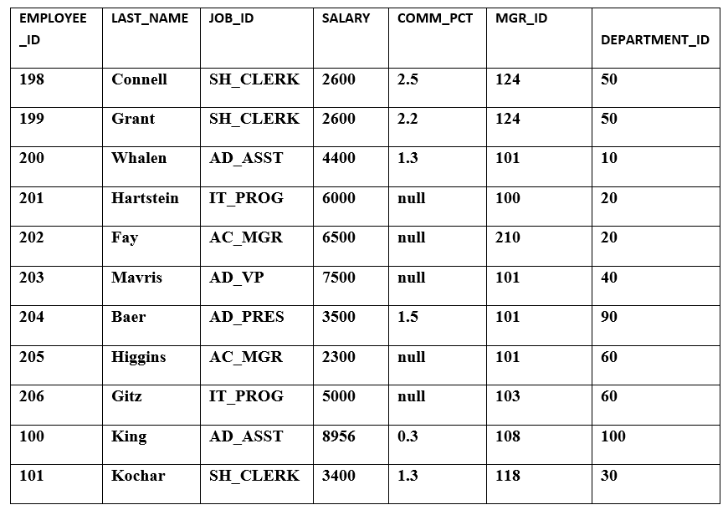
Query:
INSERT INTO EMPLOYEE VALUES (198, 'Connell', 'SH_CLERK', 2600, 2.5, 124, 50);

INSERT INTO EMPLOYEE VALUES (199, 'Grant', 'SH_CLERK', 2600, 2.2, 124, 50);

INSERT INTO EMPLOYEE VALUES (200, 'Whalen', 'AD_ASST', 4400, 1.3, 101, 10);

INSERT INTO EMPLOYEE VALUES (201, 'Hartstein', 'IT_PROG', 6000, NULL, 100, 20);

INSERT INTO EMPLOYEE VALUES (202, 'Fay', 'AC_MGR', 6500, NULL, 210, 20);

INSERT INTO EMPLOYEE VALUES (203, 'Mavris', 'AD_VP', 7500, NULL, 101, 40);

INSERT INTO EMPLOYEE VALUES (204, 'Baer', 'AD_PRES', 3500, 1.5, 101, 90);

INSERT INTO EMPLOYEE VALUES (205, 'Higgins', 'AC_MGR', 2300, NULL, 101, 60);

INSERT INTO EMPLOYEE VALUES (206, 'Gitz', 'IT_PROG', 5000, NULL, 103, 60);

INSERT INTO EMPLOYEE VALUES (100, 'King', 'AD_ASST', 8956, 0.3, 108, 100);

INSERT INTO EMPLOYEE VALUES (101, 'Kochar', 'SH_CLERK', 3400, 1.3, 118, 30);

COMMIT;
Output:
11 rows inserted.
Commit complete.

3.Question: Display LAST_NAME, JOB_ID, and EMPLOYEE_ID, with employee ID appearing first.
Query:
SELECT EMPLOYEE_ID, LAST_NAME, JOB_ID
FROM EMPLOYEE;
Output:
EMPLOYEE_ID | LAST_NAME | JOB_ID
198 | Connell | SH_CLERK
199 | Grant | SH_CLERK
200 | Whalen | AD_ASST
201 | Hartstein | IT_PROG
202 | Fay | AC_MGR
203 | Mavris | AD_VP
204 | Baer | AD_PRES
205 | Higgins | AC_MGR
206 | Gitz | IT_PROG
100 | King | AD_ASST
101 | Kochar | SH_CLERK

4. Question: Display details of all employees of department 60.
Query:
SELECT *
FROM EMPLOYEE
WHERE DEPARTMENT_ID = 60;
Output:
ID | LAST_NAME | JOB_ID | SALARY | COMM | MGR_ID | DEPT
205 | Higgins | AC_MGR | 2300 | NULL | 101 | 60
206 | Gitz | IT_PROG | 5000 | NULL | 103 | 60

5.Question: Display details of the employee whose last name is King.
Query:
SELECT *
FROM EMPLOYEE
WHERE LAST_NAME = 'King';
Output:
EMPLOYEE_ID | LAST_NAME | JOB_ID | SALARY | COMM_PCT | MGR_ID | DEPARTMENT_ID
100 | King | AD_ASST | 8956 | 0.3 | 108 | 100

6. Question: Display unique JOB_ID and give the column alias JOB_TITLE.
Query:
SELECT DISTINCT JOB_ID AS JOB_TITLE
FROM EMPLOYEE;
Output:
JOB_TITLE
SH_CLERK
AD_ASST
IT_PROG
AC_MGR
AD_VP
AD_PRES

7. Question: Display last name, salary, and salary increased by Rs. 300 as Increased Salary.
Query:
SELECT LAST_NAME,
SALARY,
SALARY + 300 AS "Increased Salary"
FROM EMPLOYEE;
Output:
LAST_NAME | SALARY | Increased Salary
Connell | 2600 | 2900
Grant | 2600 | 2900
Whalen | 4400 | 4700
Hartstein | 6000 | 6300
Fay | 6500 | 6800
Mavris | 7500 | 7800
Baer | 3500 | 3800
Higgins | 2300 | 2600
Gitz | 5000 | 5300
King | 8956 | 9256
Kochar | 3400 | 3700

8. Question: Display last name, salary, annual compensation and a one-time bonus of Rs.100.
Query:
SELECT LAST_NAME,
SALARY,
SALARY * 12 AS "Annual Compensation",
SALARY * 12 + 100 AS "Annual Compensation + Bonus"
FROM EMPLOYEE;
Output:
LAST_NAME | SALARY | Annual Compensation | Annual Compensation + Bonus
Connell | 2600 | 31200 | 31300
Grant | 2600 | 31200 | 31300
Whalen | 4400 | 52800 | 52900
Hartstein | 6000 | 72000 | 72100
Fay | 6500 | 78000 | 78100
Mavris | 7500 | 90000 | 90100
Baer | 3500 | 42000 | 42100
Higgins | 2300 | 27600 | 27700
Gitz | 5000 | 60000 | 60100
King | 8956 | 107472 | 107572
Kochar | 3400 | 40800 | 40900

9. Question: Display details of employees who get commission.
Query:
SELECT *
FROM EMPLOYEE
WHERE COMM_PCT IS NOT NULL;
Output:
ID | LAST_NAME | JOB_ID | SALARY | COMM | MGR | DEPT
198 | Connell | SH_CLERK | 2600 | 2.5 | 124 | 50
199 | Grant | SH_CLERK | 2600 | 2.2 | 124 | 50
200 | Whalen | AD_ASST | 4400 | 1.3 | 101 | 10
204 | Baer | AD_PRES | 3500 | 1.5 | 101 | 90
100 | King | AD_ASST | 8956 | 0.3 | 108 | 100
101 | Kochar | SH_CLERK | 3400 | 1.3 | 118 | 30

10. Question: Display details of employees who do not get commission.
Query:
SELECT *
FROM EMPLOYEE
WHERE COMM_PCT IS NULL;
Output:
ID | LAST_NAME | JOB_ID | SALARY | COMM | MGR | DEPT
201 | Hartstein | IT_PROG | 6000 | NULL | 100 | 20
202 | Fay | AC_MGR | 6500 | NULL | 210 | 20
203 | Mavris | AD_VP | 7500 | NULL | 101 | 40
205 | Higgins | AC_MGR | 2300 | NULL | 101 | 60
206 | Gitz | IT_PROG | 5000 | NULL | 103 | 60

11. Question: Display Employee_id, Department_id, and Salary where salary > 5000.
Query:
SELECT EMPLOYEE_ID, DEPARTMENT_ID, SALARY
FROM EMPLOYEE
WHERE SALARY > 5000;
Output:
EMPLOYEE_ID | DEPARTMENT_ID | SALARY
201 | 20 | 6000
202 | 20 | 6500
203 | 40 | 7500
100 | 100 | 8956

12.Question: Display last name and salary where salary is between 4000 and 7000.
Query:
SELECT LAST_NAME, SALARY
FROM EMPLOYEE
WHERE SALARY BETWEEN 4000 AND 7000;
Output:
LAST_NAME | SALARY
Whalen | 4400
Hartstein | 6000
Fay | 6500

13. Question: Display details of employees whose salary is 6000, 6500, or 7000.
Query:
SELECT *
FROM EMPLOYEE
WHERE SALARY IN (6000, 6500, 7000);
Output:
EMPLOYEE_ID | LAST_NAME | JOB_ID | SALARY | COMM | MGR | DEPT
201 | Hartstein | IT_PROG | 6000 | NULL | 100 | 20
202 | Fay | AC_MGR | 6500 | NULL | 210 | 20

14. Question: Display details of employees working in departments 10, 20, 30, or 50.
Query:
SELECT *
FROM EMPLOYEE
WHERE DEPARTMENT_ID IN (10, 20, 30, 50);
Output:
ID | LAST_NAME | DEPT
198 | Connell | 50
199 | Grant | 50
200 | Whalen | 10
201 | Hartstein | 20
202 | Fay | 20
101 | Kochar | 30

15.Question: Display details of employees whose salary is not equal to 5000.
Query:
SELECT *
FROM EMPLOYEE
WHERE SALARY <> 5000;
Output:
All employees except Gitz, because Gitz's salary is 5000.

16. Question: Display details of all CLERKS working in the organization.
Query:
SELECT *
FROM EMPLOYEE
WHERE JOB_ID LIKE '%CLERK%';
Output:
EMPLOYEE_ID | LAST_NAME | JOB_ID
198 | Connell | SH_CLERK
199 | Grant | SH_CLERK
101 | Kochar | SH_CLERK

17. Question: Change their JOB_ID to Grade_A and display the updated table.
Query:
UPDATE EMPLOYEE
SET JOB_ID = 'Grade_A'
WHERE SALARY > 5000;

COMMIT;

SELECT *
FROM EMPLOYEE;
Output:
4 rows updated.
Commit complete.
Updated employees:
EMPLOYEE_ID | LAST_NAME | JOB_ID | SALARY
201 | Hartstein | Grade_A | 6000
202 | Fay | Grade_A | 6500
203 | Mavris | Grade_A | 7500
100 | King | Grade_A | 8956

18. Question: Display employees who are either CLERK, PROGRAMMER, or ASSISTANT.
Query:
SELECT *
FROM EMPLOYEE
WHERE JOB_ID LIKE '%CLERK%'
OR JOB_ID LIKE '%PROG%'
OR JOB_ID LIKE '%ASST%';
Output:
EMPLOYEE_ID | LAST_NAME | JOB_ID
198 | Connell | SH_CLERK
199 | Grant | SH_CLERK
200 | Whalen | AD_ASST
201 | Hartstein | IT_PROG
206 | Gitz | IT_PROG
100 | King | AD_ASST
101 | Kochar | SH_CLERK

19. Question: Display employees whose designation is CLERK and salary is less than 3000.
Query:
SELECT *
FROM EMPLOYEE
WHERE JOB_ID LIKE '%CLERK%'
AND SALARY < 3000;
Output:
EMPLOYEE_ID | LAST_NAME | JOB_ID | SALARY
198 | Connell | SH_CLERK | 2600
199 | Grant | SH_CLERK | 2600

20. Question: Display Last_Name and Mgr_id of employees whose salary is above 3000 and who work under manager 101.
Query:
SELECT LAST_NAME, MGR_ID
FROM EMPLOYEE
WHERE SALARY > 3000
AND MGR_ID = 101;
Output:
LAST_NAME | MGR_ID
Whalen | 101
Mavris | 101
Baer | 101

